The Athanasian Creed
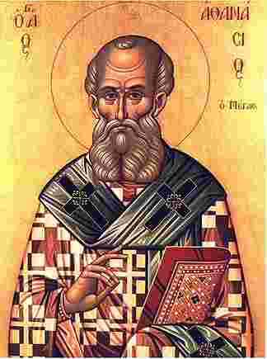
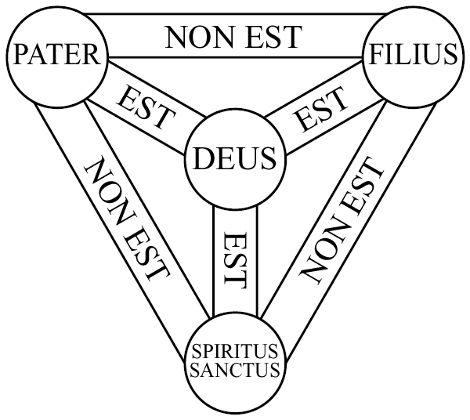
This lengthy confession of faith gets its name from Saint Athanasius, the fourth century bishop of Alexandria. Athanasius is known for his struggle against the Arian heresy. Arians believed that Jesus was a created being and not eternal God. His greatest contribution to the church was his bringing together Eastern Church theologians (Rome) who stressed that God is three persons and Western theologians (Constantinople) who stressed that God is one. The doctrine of the Holy Trinity was the result. The creed that bears his name fully confesses the fullness of the Trinity in Father, Son and Holy Spirit, without confusing the persons or dividing the Godhead. The origin of the creed is unknown, but was probably written in the fifth or six century. The creed clearly has its basis in the teaching of Saint Augustine using some of the exact phrases as his On the Trinity (published 415AD).
Martin Luther regarded the Athanasian Creed as one of the finest productions of the church since the Apostles.
The creed seems complicated but one pastor once concluded:
“A god that you can fit inside your head isn’t God.”

